EXP NO: 01

FIND S-ALGORITHM

import csv

a = []

with open("C:/Users/ramya/Downloads/enjoysport (1) (1).csv", 'r') as csvfile:

next(csvfile)

for row in csv.reader(csvfile):

a.append(row)

print(a)

print("\nThe total number of training instances are : ",len(a))

num_attribute = len(a[0])-1

print("\nThe initial hypothesis is : ")

hypothesis = ['0']*num_attribute

print(hypothesis)

for i in range(0, len(a)):

if a[i][num_attribute] == 'yes':

print ("\nInstance ", i+1, "is", a[i], " and is Positive Instance")

for j in range(0, num_attribute):

if hypothesis[j] == '0' or hypothesis[j] == a[i][j]:

hypothesis[j] = a[i][j]

else:

hypothesis[j] = '?'

print("The hypothesis for the training instance", i+1, " is: " , hypothesis, "\n")

if a[i][num_attribute] == 'no':

print ("\nInstance ", i+1, "is", a[i], " and is Negative Instance Hence Ignored")

print("The hypothesis for the training instance", i+1, " is: " , hypothesis, "\n")

print("\nThe Maximally specific hypothesis for the training instance is ", hypothesis)

OUTPUT: 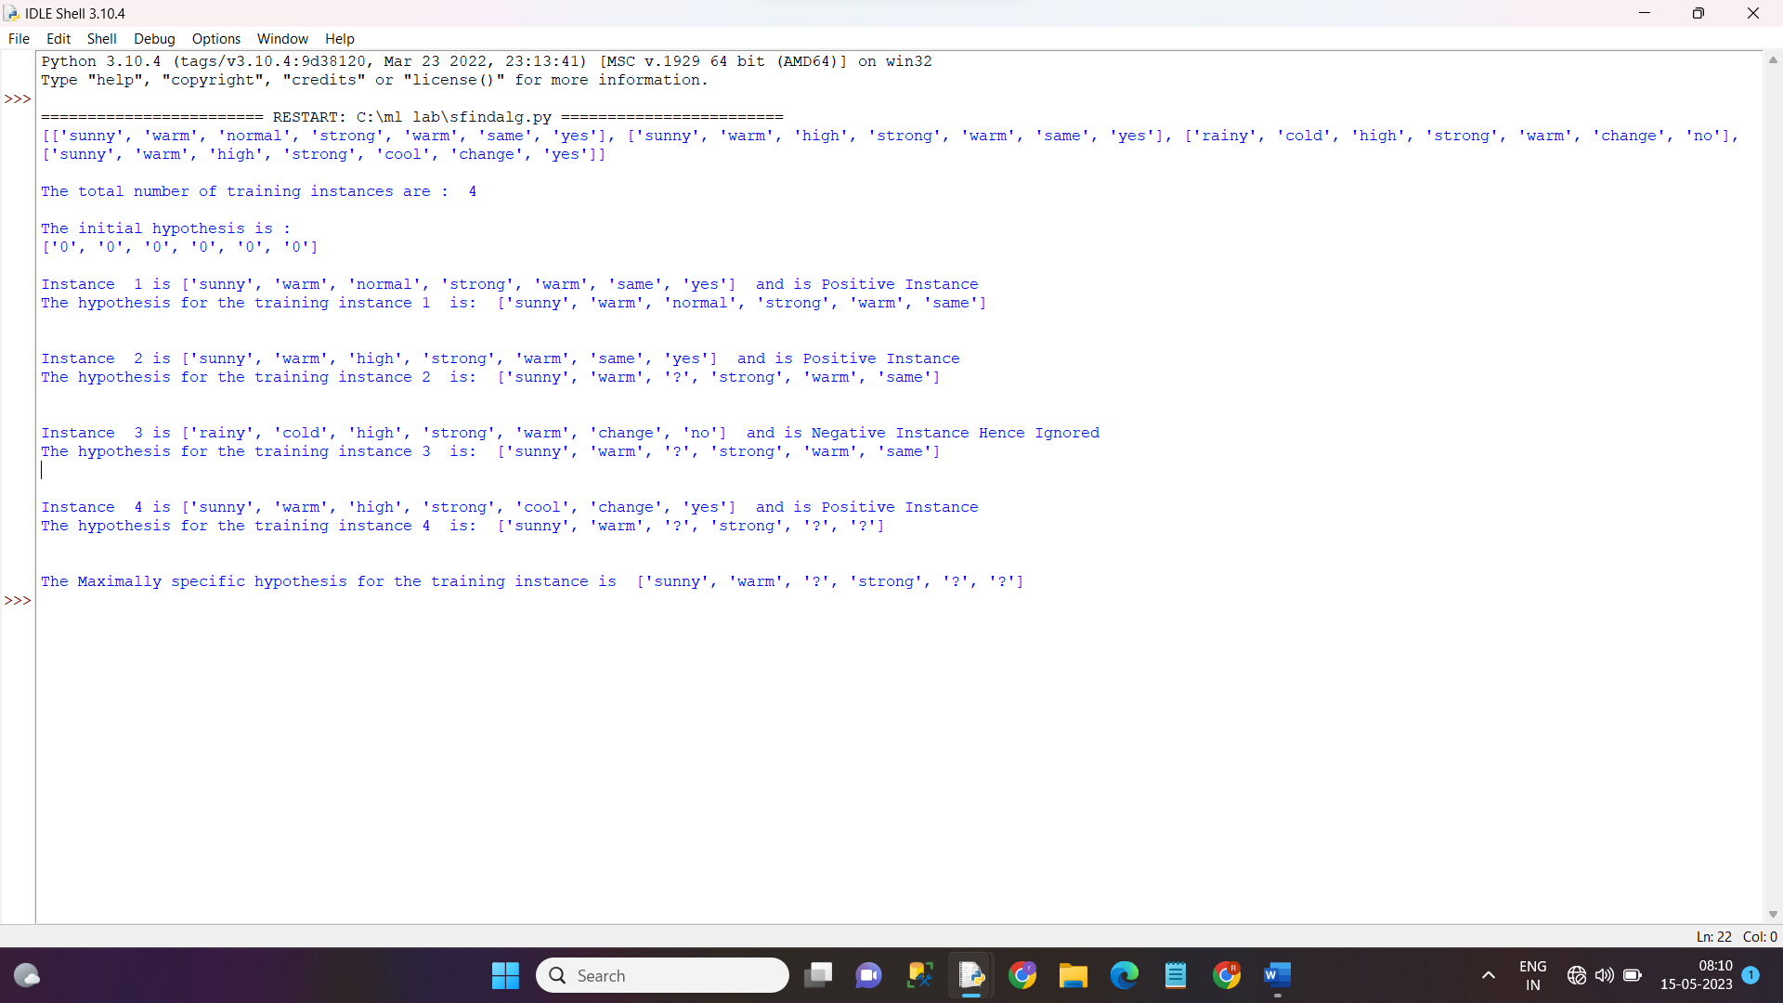

EXP NO:02

import numpy as np

import pandas as pd

data = pd.read_csv("C:\ml lab\enjoysport (1) (1).csv")

concepts = np.array(data.iloc[:,0:-1])

print("\nInstances are:\n",concepts)

target = np.array(data.iloc[:,-1])

print("\nTarget Values are: ",target)

def learn(concepts, target):

specific_h = concepts[0].copy()

print("\nInitialization of specific_h and genearal_h")

print("\nSpecific Boundary: ", specific_h)

general_h = [["?" for i in range(len(specific_h))] for i in range(len(specific_h))]

print("\nGeneric Boundary: ",general_h)

for i, h in enumerate(concepts):

print("\nInstance", i+1 , "is ", h)

if target[i] == "yes":

print("Instance is Positive ")

for x in range(len(specific_h)):

if h[x]!= specific_h[x]:

specific_h[x] ='?'

general_h[x][x] ='?'

if target[i] == "no":

print("Instance is Negative ")

for x in range(len(specific_h)):

if h[x]!= specific_h[x]:

general_h[x][x] = specific_h[x]

else:

general_h[x][x] = '?'

print("Specific Bundary after ", i+1, "Instance is ", specific_h)

print("Generic Boundary after ", i+1, "Instance is ", general_h)

print("\n")

OUTPUT:

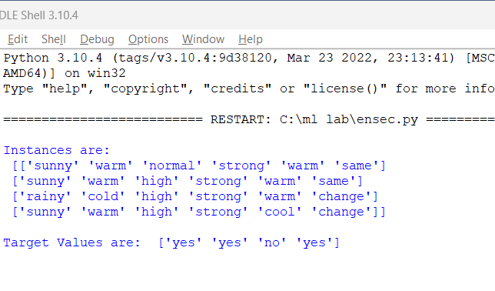

EXP NO : 03

import pandas as pd

import math

import numpy as np

data = pd.read_csv('C:/ml lab/3-dataset.csv')

features = [feat for feat in data]

features.remove("answer")

# Create a class named Node with four members children, value, isLeaf and pred.

class Node:

def __init__(self):

self.children = []

self.value = ""

self.isLeaf = False

self.pred = ""

# Define a function called entropy to find the entropy oof the dataset

def entropy(examples):

pos = 0.0

neg = 0.0

for _, row in examples.iterrows():

if row["answer"] == "yes":

pos += 1

else:

neg += 1

if pos == 0.0 or neg == 0.0:

return 0.0

else:

p = pos / (pos + neg)

n = neg / (pos + neg)

return -(p * math.log(p, 2) + n * math.log(n, 2))

# Define a function named info_gain to find the gain of the attribute

def info_gain(examples, attr):

uniq = np.unique(examples[attr])

#print ("\n",uniq)

gain = entropy(examples)

#print ("\n",gain)

for u in uniq:

subdata = examples[examples[attr] == u]

#print ("\n",subdata)

sub_e = entropy(subdata)

gain -= (float(len(subdata)) / float(len(examples))) * sub_e

#print ("\n",gain)

return gain

# Define a function named ID3 to get the decision tree for the given dataset

def ID3(examples, attrs):

root = Node()

max_gain = 0

max_feat = ""

for feature in attrs:

#print ("\n",examples)

gain = info_gain(examples, feature)

if gain > max_gain:

max_gain = gain

max_feat = feature

root.value = max_feat

#print ("\nMax feature attr",max_feat)

uniq = np.unique(examples[max_feat])

#print ("\n",uniq)

for u in uniq:

#print ("\n",u)

subdata = examples[examples[max_feat] == u]

#print ("\n",subdata)

if entropy(subdata) == 0.0:

newNode = Node()

newNode.isLeaf = True

newNode.value = u

newNode.pred = np.unique(subdata["answer"])

root.children.append(newNode)

else:

dummyNode = Node()

dummyNode.value = u

new_attrs = attrs.copy()

new_attrs.remove(max_feat)

child = ID3(subdata, new_attrs)

dummyNode.children.append(child)

root.children.append(dummyNode)

return root

# Define a function named printTree to draw the decision tree

def printTree(root: Node, depth=0):

for i in range(depth):

print("\t", end="")

print(root.value, end="")

if root.isLeaf:

print(" -> ", root.pred)

print()

for child in root.children:

printTree(child, depth + 1)

# Define a function named classify to classify the new example

def classify(root: Node, new):

for child in root.children:

if child.value == new[root.value]:

if child.isLeaf:

print ("Predicted Label for new example", new," is:", child.pred)

exit

else:

classify (child.children[0], new)

# Finally, call the ID3, printTree and classify functions

root = ID3(data, features)

print("Decision Tree is:")

printTree(root)

print ("------------------")

new = {"outlook":"sunny", "temperature":"hot", "humidity":"normal", "wind":"strong"}

classify (root, new)

output: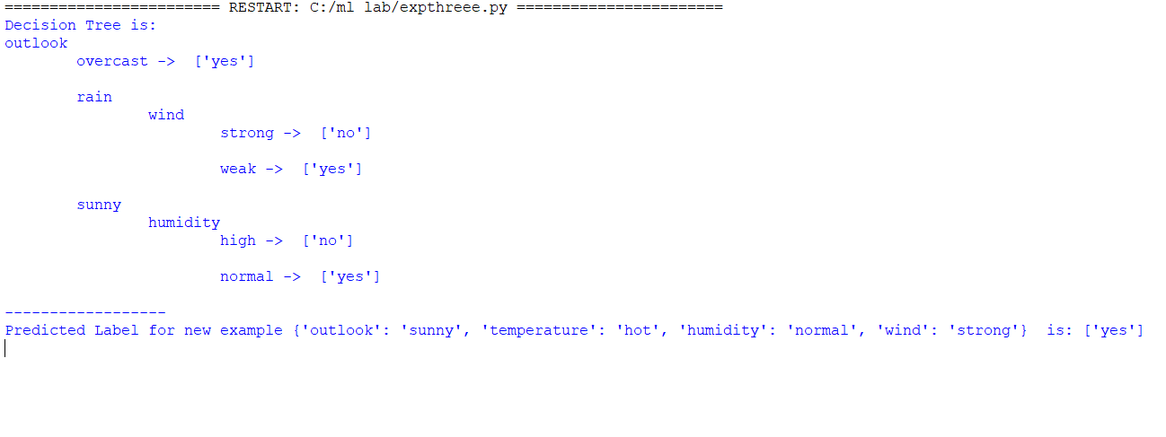

EXP NO:-04

import numpy as np

X = np.array(([2, 9], [1, 5], [3, 6]), dtype=float)

y = np.array(([92], [86], [89]), dtype=float)

X = X/np.amax(X,axis=0) #maximum of X array longitudinally

y = y/100

def sigmoid (x):

return 1/(1 + np.exp(-x))

def derivatives_sigmoid(x):

return x * (1 - x)

epoch=5 #Setting training iterations

lr=0.1 #Setting learning rate

inputlayer_neurons = 2 #number of features in data set

hiddenlayer_neurons = 3 #number of hidden layers neurons

output_neurons = 1 #number of neurons at output layer

wh=np.random.uniform(size=(inputlayer_neurons,hiddenlayer_neurons))

bh=np.random.uniform(size=(1,hiddenlayer_neurons))

wout=np.random.uniform(size=(hiddenlayer_neurons,output_neurons))

bout=np.random.uniform(size=(1,output_neurons))

for i in range(epoch):

#Forward Propogation

hinp1=np.dot(X,wh)

hinp=hinp1 + bh

hlayer_act = sigmoid(hinp)

outinp1=np.dot(hlayer_act,wout)

outinp= outinp1+bout

output = sigmoid(outinp)

EO = y-output

outgrad = derivatives_sigmoid(output)

d_output = EO * outgrad

EH = d_output.dot(wout.T)

hiddengrad = derivatives_sigmoid(hlayer_act)#how much hidden layer wts contributed to error

d_hiddenlayer = EH * hiddengrad

wout += hlayer_act.T.dot(d_output) *lr # dotproduct of nextlayererror and currentlayerop

wh += X.T.dot(d_hiddenlayer) *lr

print ("-----------Epoch-", i+1, "Starts----------")

print("Input: \n" + str(X))

print("Actual Output: \n" + str(y))

print("Predicted Output: \n" ,output)

print ("-----------Epoch-", i+1, "Ends----------\n")

print("Input: \n" + str(X))

print("Actual Output: \n" + str(y))

print("Predicted Output: \n" ,output)

OUTPUT:

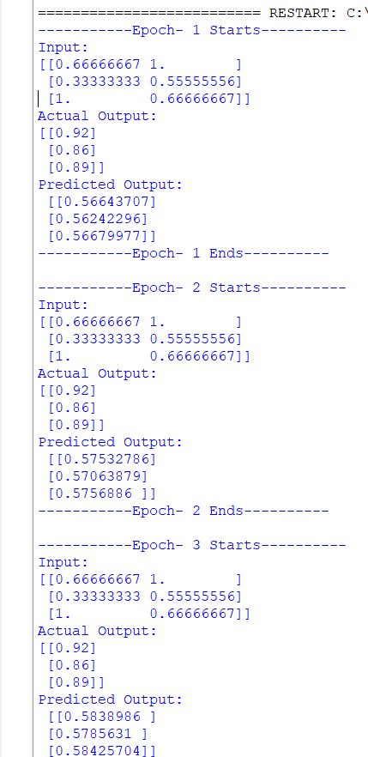

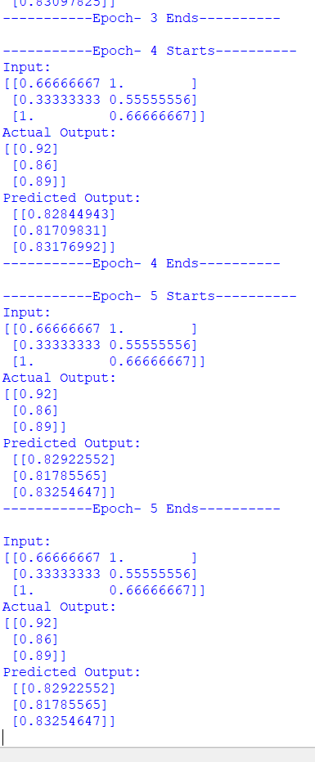

EXP NO :05

import numpy as np

import pandas as pd

dataset = pd.read_csv('C:/ml lab/mobile_prices.csv')

X = dataset.iloc[:, :-1].values

y = dataset.iloc[:, -1].values

dataset.shape

#splitting the dataset into the Training set and Test set

from sklearn.model_selection import train_test_split

X_train, X_test, y_train, y_test = train_test_split(X, y, test_size = 0.20, random_state = 42)

from sklearn.preprocessing import StandardScaler

sc = StandardScaler()

X_train = sc.fit_transform(X_train)

X_test = sc.transform(X_test)

from sklearn.neighbors import KNeighborsClassifier

classifier = KNeighborsClassifier(n_neighbors = 5, metric = 'minkowski', p = 2)

from sklearn.metrics import confusion_matrix, accuracy_score

y_pred = classifier.predict(X_test)

cm = confusion_matrix(y_test, y_pred)

print(cm)

accuracy_score(y_test, y_pred)

OUTPUT:

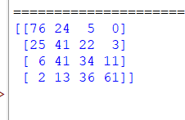

EXP NO:06

import numpy as np

import pandas as pd

dataset = pd.read_csv('C:/ml lab/breastcancer.csv')

X = dataset.iloc[:, :-1].values

y = dataset.iloc[:, -1].values

from sklearn.model_selection import train_test_split

X_train, X_test, y_train, y_test = train_test_split(X, y, test_size = 0.25, random_state = 0)

from sklearn.preprocessing import StandardScaler

sc = StandardScaler()

X_train = sc.fit_transform(X_train)

X_test = sc.transform(X_test)

from sklearn.naive_bayes import GaussianNB

classifier = GaussianNB()

classifier.fit(X_train, y_train)

GaussianNB(priors=None, var_smoothing=1e-09)

from sklearn.metrics import confusion_matrix, accuracy_score

OUTPUT:

: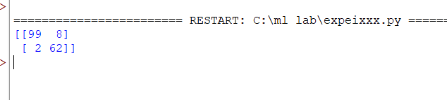

EXP NO:07

import numpy as np

import matplotlib.pyplot as plt

import pandas as pd

dataset = pd.read_csv('C:/ml lab/Salary_Data (1).csv')

X = dataset.iloc[:, :-1].values

y = dataset.iloc[:, -1].values

dataset.head()

from sklearn.model_selection import train_test_split

X_train, X_test, y_train, y_test = train_test_split(X, y, test_size = 1/3, random_state = 0)

from sklearn.linear_model import LinearRegression

regressor = LinearRegression()

regressor.fit(X_train, y_train)

LinearRegression(copy_X=True, fit_intercept=True, n_jobs=None, normalize=False)

y_pred = regressor.predict(X_test)

pd.DataFrame(data={'Actuals': y_test, 'Predictions': y_pred})

plt.scatter(X_train, y_train, color = 'red')

plt.plot(X_train, regressor.predict(X_train), color = 'blue')

plt.title('Salary vs Experience (Training set)')

plt.xlabel('Years of Experience')

plt.ylabel('Salary')

plt.show()

OUTPUT:

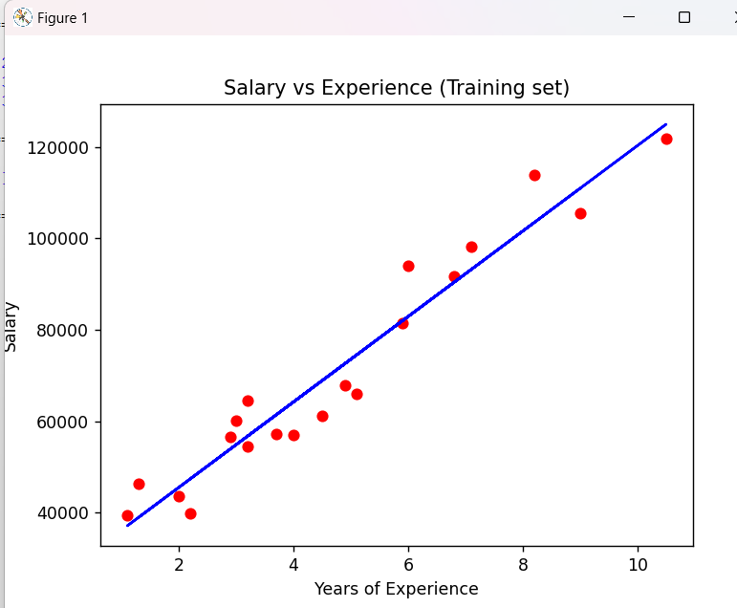

EXP NO:08

import numpy as np

import matplotlib.pyplot as plt

import pandas as pd

dataset = pd.read_csv('C:/ml lab/Position_Salaries.csv')

X = dataset.iloc[:, 1:-1].values

y = dataset.iloc[:, -1].values

from sklearn.linear_model import LinearRegression

lin_reg = LinearRegression()

lin_reg.fit(X, y)

LinearRegression(copy_X=True, fit_intercept=True, n_jobs=None, normalize=False)

from sklearn.preprocessing import PolynomialFeatures

poly_reg = PolynomialFeatures(degree = 4)

X_poly = poly_reg.fit_transform(X)

lin_reg_2 = LinearRegression()

lin_reg_2.fit(X_poly, y)

plt.scatter(X, y, color = 'red')

plt.plot(X, lin_reg.predict(X), color = 'blue')

plt.title('Truth or Bluff (Linear Regression)')

plt.xlabel('Position Level')

plt.ylabel('Salary')

plt.show()

plt.scatter(X, y, color = 'red')

plt.plot(X, lin_reg_2.predict(poly_reg.fit_transform(X)), color = 'blue')

plt.title('Truth or Bluff (Polynomial Regression)')

plt.xlabel('Position level')

plt.ylabel('Salary')

plt.show()

OUTPUT:

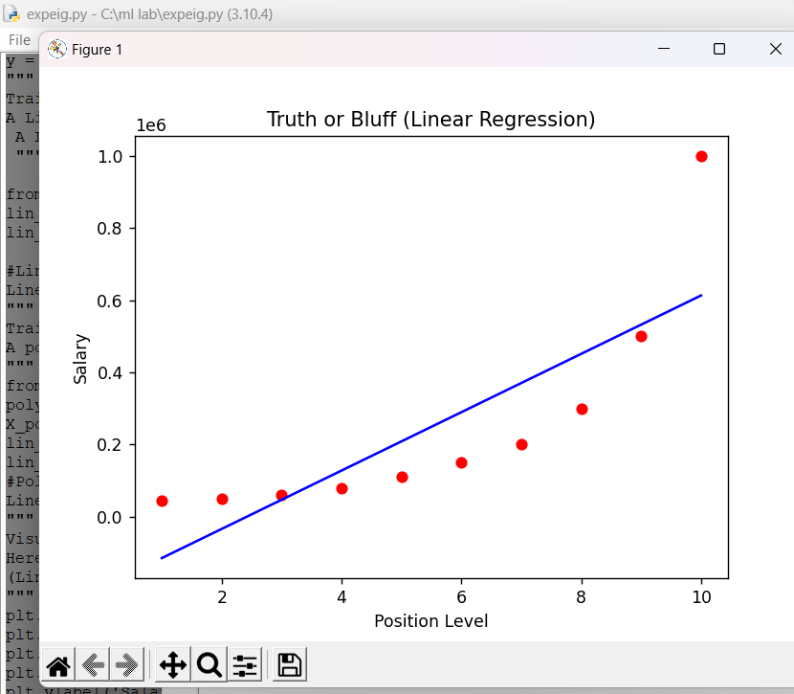

EXP NO:09

import numpy as np

import pandas as pd

dataset = pd.read_csv('C:/ml lab/breastcancer.csv')

X = dataset.iloc[:, :-1].values

y = dataset.iloc[:, -1].values

from sklearn.model_selection import train_test_split

X_train, X_test, y_train, y_test = train_test_split(X, y, test_size = 0.30, random_state = 2)

from sklearn.preprocessing import StandardScaler

rom sklearn.preprocessing import StandardScaler

sc = StandardScaler()

X_train = sc.fit_transform(X_train)

X_test = sc.transform(X_test)

from sklearn.linear_model import LogisticRegression

classifier = LogisticRegression(random_state = 0)

classifier.fit(X_train, y_train)

#Logistic Regression (LR) classifier model

LogisticRegression(C=1.0, class_weight=None, dual=False, fit_intercept=True,

intercept_scaling=1, l1_ratio=None, max_iter=100,

multi_class='warn', n_jobs=None, penalty='l2',

random_state=0, solver='warn', tol=0.0001, verbose=0,

warm_start=False)

from sklearn.metrics import confusion_matrix, accuracy_score

y_pred = classifier.predict(X_test)

cm = confusion_matrix(y_test, y_pred)

print(cm)

accuracy_score(y_test, y_pred)

output:

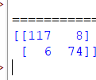

EXP NO:12

import pandas as pd

import matplotlib.pyplot as plt

import numpy as np

iris = pd.read_csv('C:/ml lab/IRIS.csv')

#first five rows of this dataset:

print(iris.head())

print(iris.describe())

#The target labels of this dataset are present in the species column, let’s have a quick look at the target labels:

print("Target Labels", iris["species"].unique())

import plotly.io as io

io.renderers.default='browser'

import plotly.express as px

fig = px.scatter(iris, x="sepal_width", y="sepal_length", color="species")

fig.show()

x = iris.drop("species", axis=1)

y = iris["species"]

from sklearn.model_selection import train_test_split

x_train, x_test, y_train, y_test = train_test_split(x, y,test_size=0.2,random_state=42)

from sklearn.neighbors import KNeighborsClassifier

knn = KNeighborsClassifier()

knn.fit(x_train, y_train)

prediction = knn.predict(x_test)

print("Prediction: {}".format(prediction))

OUTPUT:

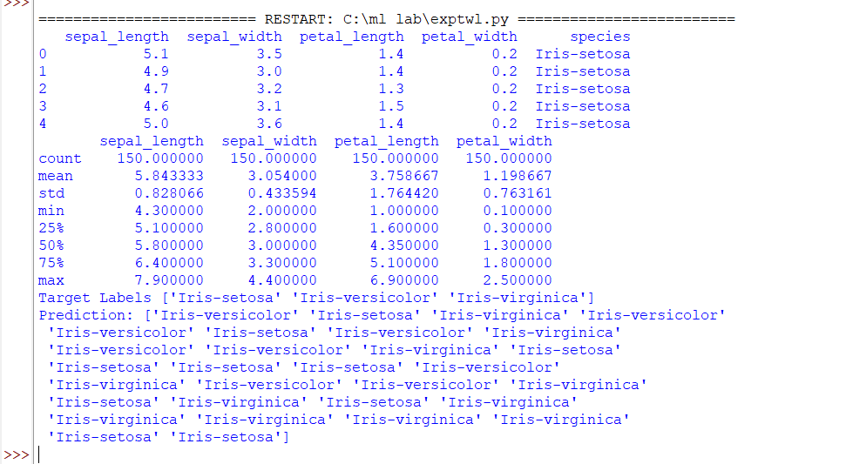

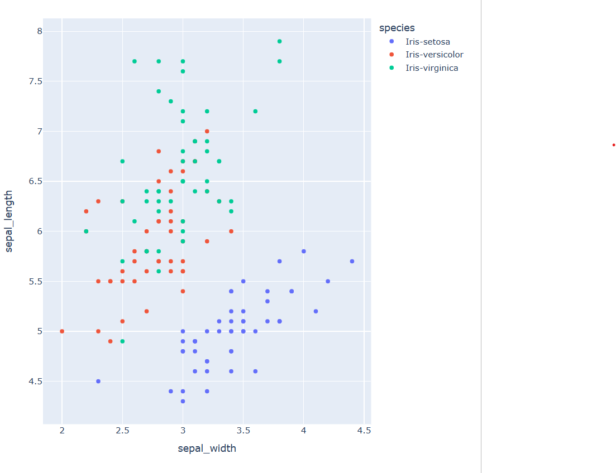

EXP NO :13

import numpy as np

import pandas as pd

import matplotlib.pyplot as plt

import seaborn as sns

from sklearn.model_selection import train_test_split

from sklearn.tree import DecisionTreeRegressor

data = pd.read_csv('C:/ml lab/CarPrice.csv')

data.head()

data.shape

data.isnull().sum()

data.info()

data.describe()

data.CarName.unique()

sns.set_style("whitegrid")

plt.figure(figsize=(15, 10))

sns.histplot(data.price)

plt.show()

print(data.corr())

plt.figure(figsize=(20, 15))

correlations = data.corr()

sns.heatmap(correlations, cmap="coolwarm", annot=True)

plt.show()

llllllllllllllllllllllllllllllllllllpredict = "price"

data = data[["symboling", "wheelbase", "carlength",

"carwidth", "carheight", "curbweight",

"enginesize", "boreratio", "stroke",

"compressionratio", "horsepower", "peakrpm",

"citympg", "highwaympg", "price"]]

x = np.array(data.drop([predict], 1))

y = np.array(data[predict])

from sklearn.model_selection import train_test_split

xtrain, xtest, ytrain, ytest = train_test_split(x, y, test_size=0.2)

from sklearn.tree import DecisionTreeRegressor

model = DecisionTreeRegressor()

model.fit(xtrain, ytrain)

predictions = model.predict(xtest)

from sklearn.metrics import mean_absolute_error

model.score(xtest, predictions)

OUTPUT:

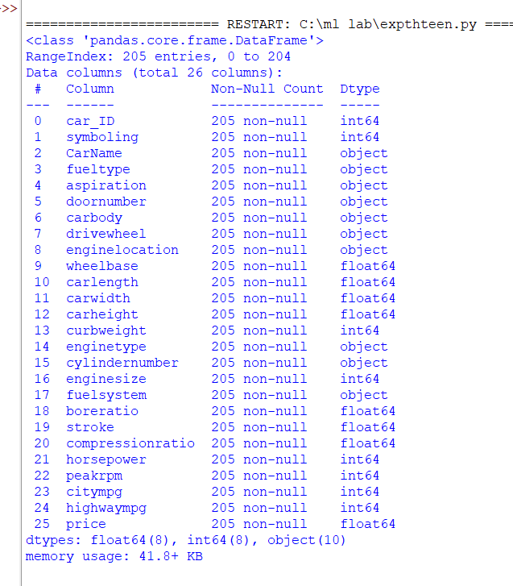

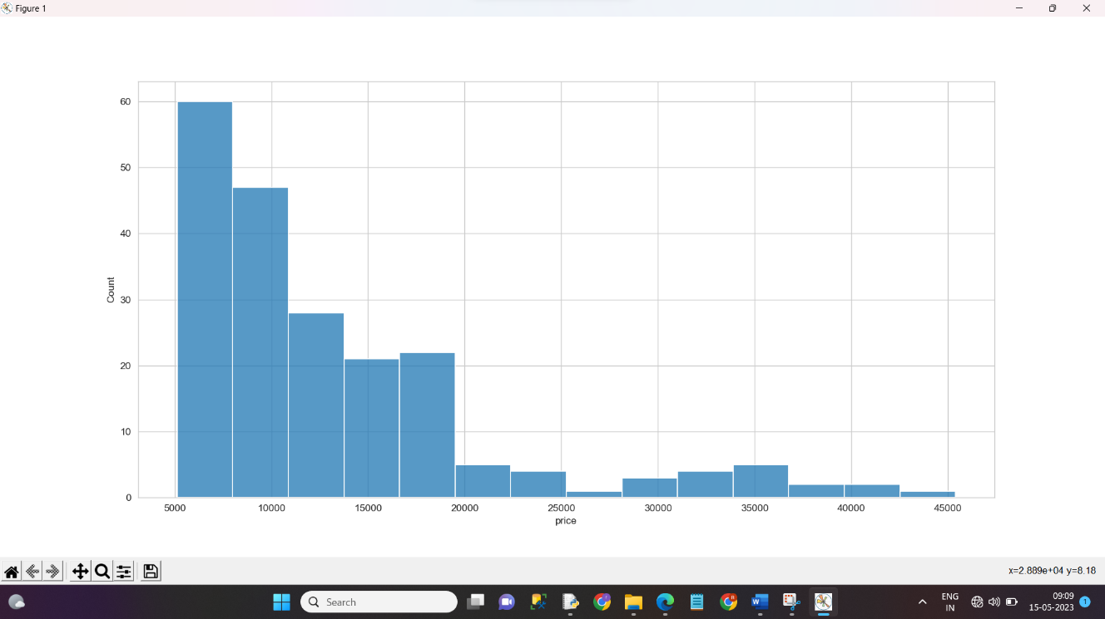

EXP NO:14

import pandas as pd

import matplotlib.pyplot as plt

import seaborn as sns

dataset = pd.read_csv('C:/ml lab/HousePricePrediction.csv')

from sklearn.feature_extraction.text import CountVectorizer

print(dataset.head(5))

dataset.shape

obj = (dataset.dtypes == 'object')

object_cols = list(obj[obj].index)

print("Categorical variables:",len(object_cols))

int_ = (dataset.dtypes == 'int')

num_cols = list(int_[int_].index)

print("Integer variables:",len(num_cols))

fl = (dataset.dtypes == 'float')

fl_cols = list(fl[fl].index)

print("Float variables:",len(fl_cols))

plt.figure(figsize=(12, 6))

sns.heatmap(dataset.corr(),

cmap = 'BrBG',

fmt = '.2f',

linewidths = 2,

annot = True)

unique_values = []

for col in object_cols:

unique_values.append(dataset[col].unique().size)

plt.figure(figsize=(10,6))

plt.title('No. Unique values of Categorical Features')

plt.xticks(rotation=90)

sns.barplot(x=object_cols,y=unique_values)

plt.figure(figsize=(18, 36))

plt.title('Categorical Features: Distribution')

plt.xticks(rotation=90)

index = 1

for col in object_cols:

y = dataset[col].value_counts()

plt.subplot(11, 4, index)

plt.xticks(rotation=90)

sns.barplot(x=list(y.index), y=y)

index += 1

dataset.drop(['Id'],

axis=1,

inplace=True)

dataset['SalePrice'] = dataset['SalePrice'].fillna(dataset['SalePrice'].mean())

new_dataset = dataset.dropna()

new_dataset.isnull().sum()

from sklearn.preprocessing import OneHotEncoder

s = (new_dataset.dtypes == 'object')

object_cols = list(s[s].index)

print("Categorical variables:")

print(object_cols)

print('No. of. categorical features: ',len(object_cols))

OH_encoder = OneHotEncoder(sparse=False)

OH_cols = pd.DataFrame(OH_encoder.fit_transform(new_dataset[object_cols]))

OH_cols.index = new_dataset.index

OH_cols.columns = OH_encoder.get_feature_names_out()

df_final = new_dataset.drop(object_cols, axis=1)

df_final = pd.concat([df_final, OH_cols], axis=1)

text_data = ['This is the first document.',

'This document is the second document.',

'And this is the third one.',

'Is this the first document?']

vectorizer = CountVectorizer()

X = vectorizer.fit_transform(text_data)

from sklearn.metrics import mean_absolute_error

from sklearn.model_selection import train_test_split

X = df_final.drop(['SalePrice'], axis=1)

Y = df_final['SalePrice']

X_train, X_valid, Y_train, Y_valid = train_test_split(X, Y, train_size=0.8, test_size=0.2, random_state=0)

from sklearn import svm

from sklearn.svm import SVC

from sklearn.metrics import mean_absolute_percentage_error

model_SVR = svm.SVR()

model_SVR.fit(X_train,Y_train)

Y_pred = model_SVR.predict(X_valid)

print(mean_absolute_percentage_error(Y_valid, Y_pred))

from sklearn.ensemble import RandomForestRegressor

model_RFR = RandomForestRegressor(n_estimators=10)

model_RFR.fit(X_train, Y_train)

Y_pred = model_RFR.predict(X_valid)

mean_absolute_percentage_error(Y_valid, Y_pred)

from sklearn.linear_model import LinearRegression

model_LR = LinearRegression()

model_LR.fit(X_train, Y_train)

Y_pred = model_LR.predict(X_valid)

print(mean_absolute_percentage_error(Y_valid, Y_pred))

OUTPUT:

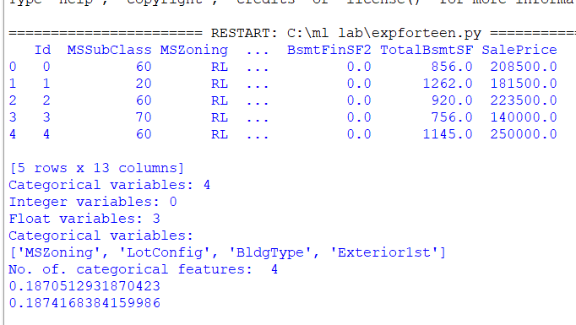

EXPNO:15

from sklearn.naive_bayes import GaussianNB

from sklearn.naive_bayes import MultinomialNB

from sklearn import datasets

from sklearn.metrics import confusion_matrix

iris = datasets.load_iris()

gnb = GaussianNB()

mnb = MultinomialNB()

y_pred_gnb = gnb.fit(iris.data, iris.target).predict(iris.data)

cnf_matrix_gnb = confusion_matrix(iris.target, y_pred_gnb)

print(cnf_matrix_gnb)

y_pred_mnb = mnb.fit(iris.data, iris.target).predict(iris.data)

cnf_matrix_mnb = confusion_matrix(iris.target, y_pred_mnb)

print(cnf_matrix_mnb)

OUTPUT:

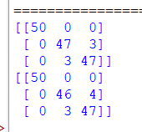

EXP NO:16

import pandas as pd

from sklearn.model_selection import train_test_split

from sklearn.tree import DecisionTreeClassifier

from sklearn.linear_model import LogisticRegression

from sklearn.naive_bayes import BernoulliNB

from sklearn.neighbors import KNeighborsClassifier

from sklearn.linear_model import PassiveAggressiveClassifier

from sklearn.metrics import classification_report

iris = pd.read_csv('C:/ml lab/IRIS.csv')

print(iris.head())

x = iris.drop("species", axis=1)

y = iris["species"]

x_train, x_test, y_train, y_test = train_test_split(x, y, test_size=10, random_state=42)

decision_tree = DecisionTreeClassifier()

logistic_regression = LogisticRegression(max_iter=1000) # Increase max_iter value

k_nearest_classifier = KNeighborsClassifier()

bernoulli_naive_bayes = BernoulliNB()

passive_aggressive = PassiveAggressiveClassifier()

k_nearest_classifier.fit(x_train, y_train)

decision_tree.fit(x_train, y_train)

logistic_regression.fit(x_train, y_train)

passive_aggressive.fit(x_train, y_train)

data1 = {

"Classification Algorithms": [

"KNN Classifier",

"Decision Tree Classifier",

"Logistic Regression",

"Passive Aggressive Classifier"

],

"Score": [

k_nearest_classifier.score(x, y),

decision_tree.score(x, y),

logistic_regression.score(x, y),

passive_aggressive.score(x, y)

]

}

score = pd.DataFrame(data1)

print(score)

OUTPUT:

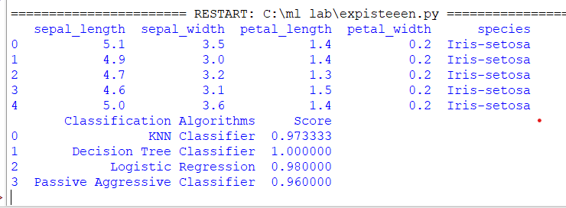

EXP NO:17

import numpy as np

import pandas as pd

import matplotlib.pyplot as plt

import seaborn as sns

from sklearn.model_selection import train_test_split

from sklearn.preprocessing import StandardScaler

from sklearn.linear_model import LogisticRegression

from sklearn.metrics import accuracy_score

sns.set()

import plotly.io as io

io.renderers.default='browser'

data = pd.read_csv('C:/ml lab/mobile_prices.csv')

print(data.head())

plt.figure(figsize=(12, 10))

sns.heatmap(data.corr(), annot=True, cmap="coolwarm", linecolor='white', linewidths=1)

#data preparation

x = data.iloc[:, :-1].values

y = data.iloc[:, -1].values

x = StandardScaler().fit_transform(x)

x_train, x_test, y_train, y_test = train_test_split(x, y, test_size=0.20, random_state=0)

# Logistic Regression algorithm provided by Scikit-learn:

from sklearn.linear_model import LogisticRegression

lreg = LogisticRegression()

lreg.fit(x_train, y_train)

y_pred = lreg.predict(x_test)

#accuracy of the model:

accuracy = accuracy_score(y_test, y_pred) * 100

print("Accuracy of the Logistic Regression Model: ",accuracy)

#predictions made by the model:

print(y_pred)

#Let’s have a look at the number of mobile phones classified for each price range:

(unique, counts) = np.unique(y_pred, return_counts=True)

price_range = np.asarray((unique, counts)).T

print(price_range)

OUTPUT:

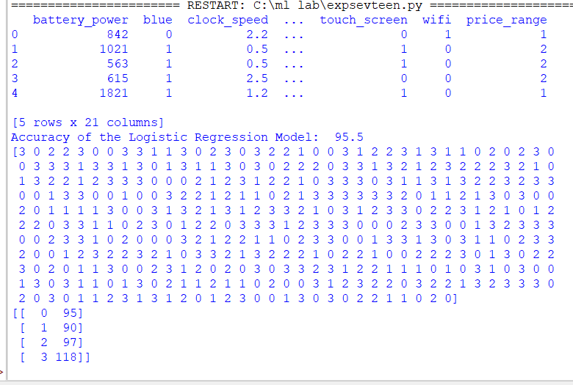

EXP NO:11

import pandas as pd

import numpy as np

import plotly.express as px

import plotly.graph_objects as go

import plotly.io as pio

pio.templates.default = "plotly_white"

import plotly.io as io

io.renderers.default='browser'

data = pd.read_csv('C:/ml lab/CREDITSCORE.csv')

print(data.head())

print(data.info())

print(data.isnull().sum())

#The dataset doesn’t have any null values. As this dataset is labelled, let’s have a look at the Credit_Score column values:

data["Credit_Score"].value_counts()

data.shape

fig = px.box(data,

x="Occupation",

color="Credit_Score",

title="Credit Scores Based on Occupation",

color_discrete_map={'Poor':'red',

'Standard':'yellow',

'Good':'green'})

fig.show()

fig = px.box(data,

x="Credit_Score",

y="Annual_Income",

color="Credit_Score",

title="Credit Scores Based on Annual Income",

color_discrete_map={'Poor':'red',

'Standard':'yellow',

'Good':'green'})

fig.update_traces(quartilemethod="exclusive")

fig.show()

fig = px.box(data,

x="Credit_Score",

y="Monthly_Inhand_Salary",

color="Credit_Score",

title="Credit Scores Based on Monthly Inhand Salary",

color_discrete_map={'Poor':'red',

'Standard':'yellow',

'Good':'green'})

fig.update_traces(quartilemethod="exclusive")

fig.show()

fig = px.box(data,

x="Credit_Score",

y="Num_Bank_Accounts",

color="Credit_Score",

title="Credit Scores Based on Number of Bank Accounts",

color_discrete_map={'Poor':'red',

'Standard':'yellow',

'Good':'green'})

fig.update_traces(quartilemethod="exclusive")

fig.show()

# impact on credit scores based on the number of credit cards you have:

fig = px.box(data,

x="Credit_Score",

y="Num_Credit_Card",

color="Credit_Score",

title="Credit Scores Based on Number of Credit cards",

color_discrete_map={'Poor':'red',

'Standard':'yellow',

'Good':'green'})

fig.update_traces(quartilemethod="exclusive")

fig.show()

fig = px.box(data,

x="Credit_Score",

y="Interest_Rate",

color="Credit_Score",

title="Credit Scores Based on the Average Interest rates",

color_discrete_map={'Poor':'red',

'Standard':'yellow',

'Good':'green'})

fig.update_traces(quartilemethod="exclusive")

fig.show()

data["Credit_Mix"] = data["Credit_Mix"].map({"Standard": 1,

"Good": 2,

"Bad": 0})

from sklearn.model_selection import train_test_split

x = np.array(data[["Annual_Income", "Monthly_Inhand_Salary",

"Num_Bank_Accounts", "Num_Credit_Card",

"Interest_Rate", "Num_of_Loan",

"Delay_from_due_date", "Num_of_Delayed_Payment",

"Credit_Mix", "Outstanding_Debt",

"Credit_History_Age", "Monthly_Balance"]])

y = np.array(data["Credit_Score"])

xtrain, xtest, ytrain, ytest = train_test_split(x, y,

test_size=0.33,

random_state=42)

from sklearn.ensemble import RandomForestClassifier

model = RandomForestClassifier()

model.fit(xtrain, ytrain)

print("Credit Score Prediction : ")

a = float(input("Annual Income: "))

b = float(input("Monthly Inhand Salary: "))

c = float(input("Number of Bank Accounts: "))

d = float(input("Number of Credit cards: "))

e = float(input("Interest rate: "))

f = float(input("Number of Loans: "))

g = float(input("Average number of days delayed by the person: "))

h = float(input("Number of delayed payments: "))

i = input("Credit Mix (Bad: 0, Standard: 1, Good: 3) : ")

j = float(input("Outstanding Debt: "))

k = float(input("Credit History Age: "))

l = float(input("Monthly Balance: "))

features = np.array([[a, b, c, d, e, f, g, h, i, j, k, l]])

print("Predicted Credit Score = ", model.predict(features))

output:

========================================================================= RESTART: C:/ml lab/explaavan.py ===========================================================================

ID Customer_ID ... Monthly_Balance Credit_Score

0 5634 3392 ... 312.494089 Good

1 5635 3392 ... 284.629162 Good

2 5636 3392 ... 331.209863 Good

3 5637 3392 ... 223.451310 Good

4 5638 3392 ... 341.489231 Good

[5 rows x 28 columns]

<class 'pandas.core.frame.DataFrame'>

RangeIndex: 100000 entries, 0 to 99999

Data columns (total 28 columns):

# Column Non-Null Count Dtype

--- ------ -------------- -----

0 ID 100000 non-null int64

1 Customer_ID 100000 non-null int64

2 Month 100000 non-null int64

3 Name 100000 non-null object

4 Age 100000 non-null float64

5 SSN 100000 non-null float64

6 Occupation 100000 non-null object

7 Annual_Income 100000 non-null float64

8 Monthly_Inhand_Salary 100000 non-null float64

9 Num_Bank_Accounts 100000 non-null float64

10 Num_Credit_Card 100000 non-null float64

11 Interest_Rate 100000 non-null float64

12 Num_of_Loan 100000 non-null float64

13 Type_of_Loan 100000 non-null object

14 Delay_from_due_date 100000 non-null float64

15 Num_of_Delayed_Payment 100000 non-null float64

16 Changed_Credit_Limit 100000 non-null float64

17 Num_Credit_Inquiries 100000 non-null float64

18 Credit_Mix 100000 non-null object

19 Outstanding_Debt 100000 non-null float64

20 Credit_Utilization_Ratio 100000 non-null float64

21 Credit_History_Age 100000 non-null float64

22 Payment_of_Min_Amount 100000 non-null object

23 Total_EMI_per_month 100000 non-null float64

24 Amount_invested_monthly 100000 non-null float64

25 Payment_Behaviour 100000 non-null object

26 Monthly_Balance 100000 non-null float64

27 Credit_Score 100000 non-null object

dtypes: float64(18), int64(3), object(7)

memory usage: 21.4+ MB

None

ID 0

Customer_ID 0

Month 0

Name 0

Age 0

SSN 0

Occupation 0

Annual_Income 0

Monthly_Inhand_Salary 0

Num_Bank_Accounts 0

Num_Credit_Card 0

Interest_Rate 0

Num_of_Loan 0

Type_of_Loan 0

Delay_from_due_date 0

Num_of_Delayed_Payment 0

Changed_Credit_Limit 0

Num_Credit_Inquiries 0

Credit_Mix 0

Outstanding_Debt 0

Credit_Utilization_Ratio 0

Credit_History_Age 0

Payment_of_Min_Amount 0

Total_EMI_per_month 0

Amount_invested_monthly 0

Payment_Behaviour 0

Monthly_Balance 0

Credit_Score 0

dtype: int64

Credit Score Prediction :

Annual Income:

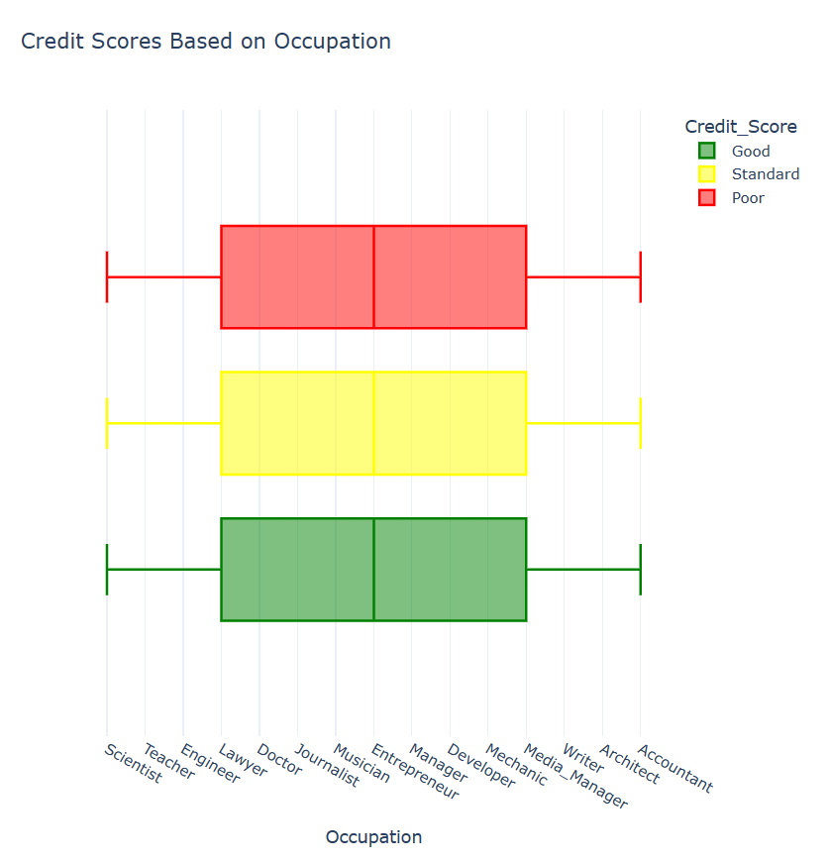

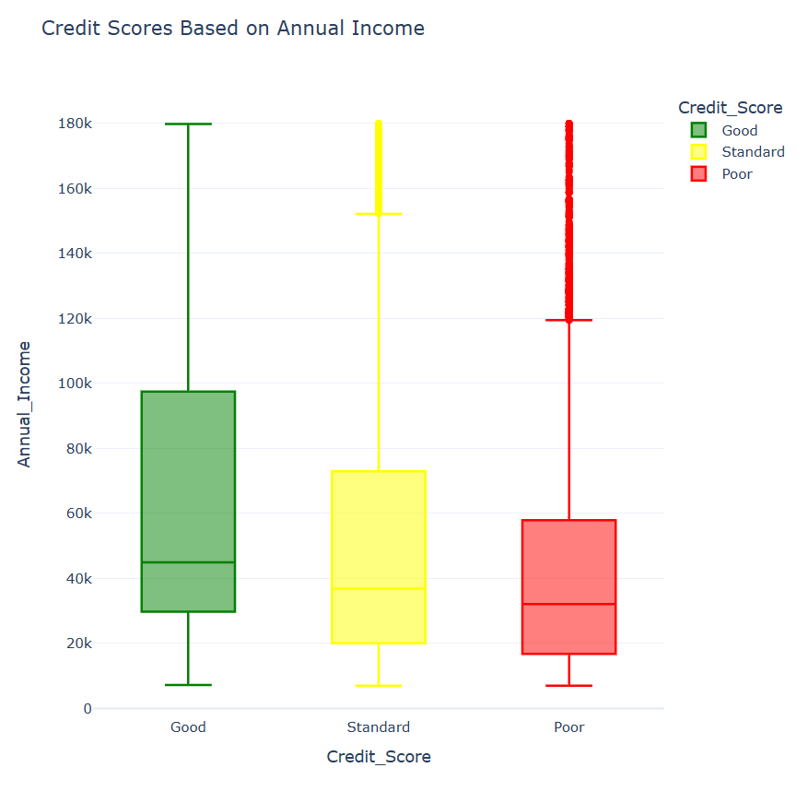

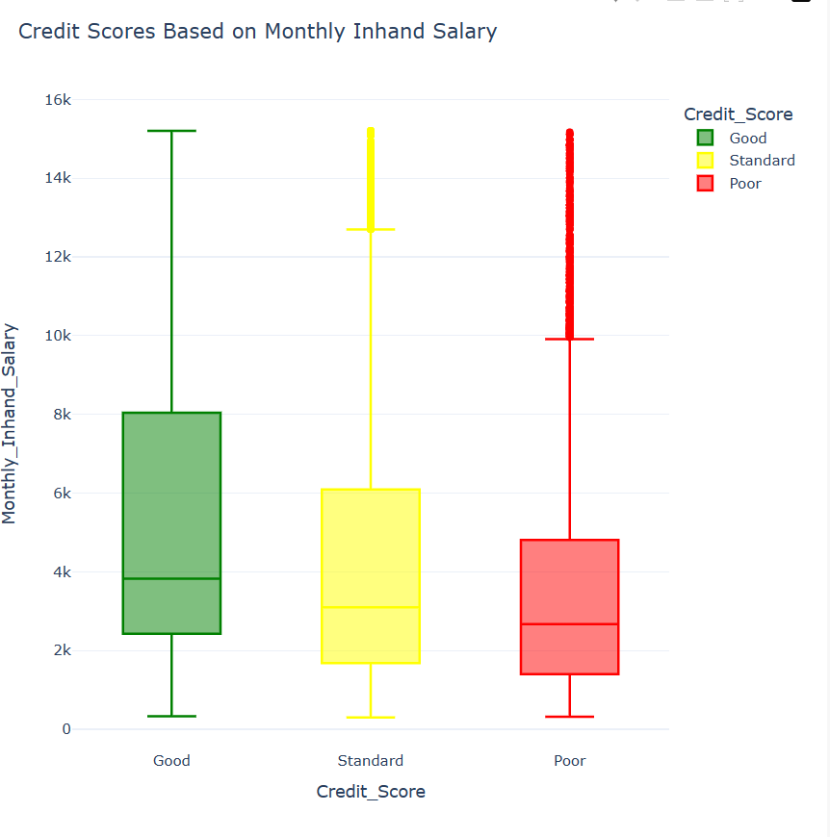

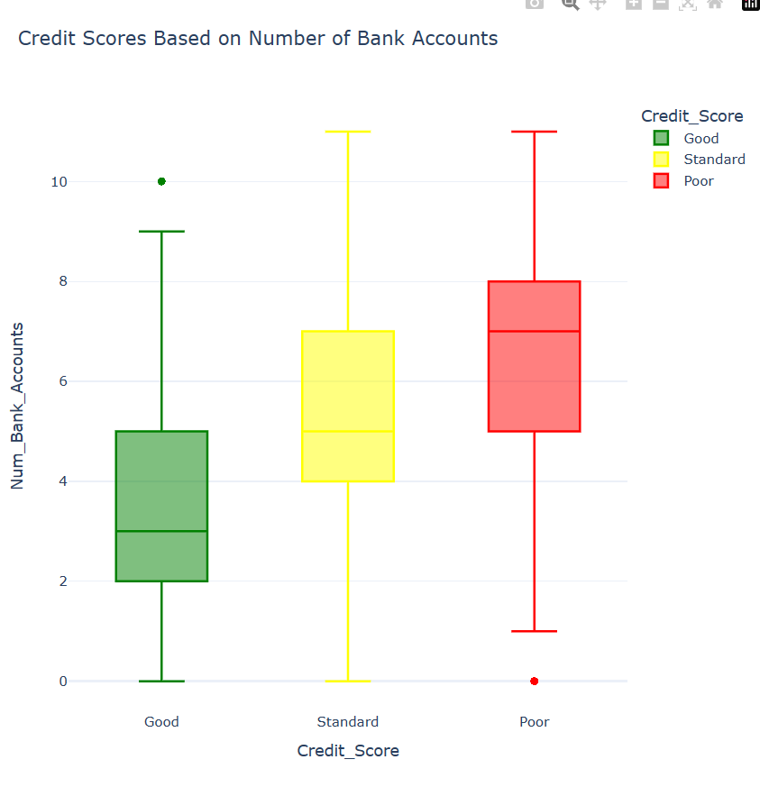

EXP NO:18

from sklearn import datasets

import numpy as np

from sklearn.model_selection import train_test_split

from sklearn.linear_model import Perceptron

from sklearn.preprocessing import StandardScaler

from sklearn.metrics import accuracy_score

iris = datasets.load_iris()

X = iris.data[:, [2, 3]]

y = iris.target

X_train, X_test, y_train, y_test = train_test_split(

X, y, test_size=0.3, random_state=1, stratify=y)

sc = StandardScaler()

sc.fit(X_train)

X_train_std = sc.transform(X_train)

X_test_std = sc.transform(X_test)

ppn = Perceptron(eta0=0.1, random_state=1)

ppn.fit(X_train_std, y_train)

y_pred = ppn.predict(X_test_std)

print('Accuracy: %.3f' % accuracy_score(y_test, y_pred))

print('Accuracy: %.3f' % ppn.score(X_test_std, y_test))

output:

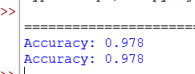

EXPNO:19

import numpy as np

import pandas as pd

dataset = pd.read_csv('C:/ml lab/breastcancer.csv')

X = dataset.iloc[:, :-1].values

y = dataset.iloc[:, -1].values

from sklearn.model_selection import train_test_split

X_train, X_test, y_train, y_test = train_test_split(X, y, test_size = 0.25, random_state = 0)

from sklearn.preprocessing import StandardScaler

sc = StandardScaler()

X_train = sc.fit_transform(X_train)

X_test = sc.transform(X_test)

from sklearn.naive_bayes import GaussianNB

classifier = GaussianNB()

classifier.fit(X_train, y_train)

built using a decision tree classifier.

from sklearn.metrics import confusion_matrix, accuracy_score

y_pred = classifier.predict(X_test)

cm = confusion_matrix(y_test, y_pred)

print(cm)

accuracy_score(y_test, y_pred)

OUTPUT:

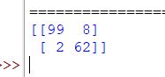

EXPNO:10

from sklearn.mixture import GaussianMixture

import sklearn.metrics as metrics

import pandas as pd

import numpy as np

import matplotlib.pyplot as plt

dataset = pd.read_csv('C:/ml lab/3-dataset.csv')

X = pd.get_dummies(dataset.iloc[:, :-1])

y = dataset['answer'].map({'no': 0, 'yes': 1})

plt.figure(figsize=(14, 7))

colormap = np.array(['red', 'lime'])

plt.subplot(1, 3, 1)

plt.title('Real')

plt.scatter(X['outlook_sunny'], X['humidity_high'], c=colormap[y])

gmm = GaussianMixture(n_components=2, random_state=0).fit(X)

y_cluster_gmm = gmm.predict(X)

plt.subplot(1, 3, 3)

plt.title('GMM Classification')

plt.scatter(X['outlook_sunny'], X['humidity_high'], c=colormap[y_cluster_gmm])

print('The accuracy score of EM:', metrics.accuracy_score(y, y_cluster_gmm))

print('The Confusion matrix of EM:\n', metrics.confusion_matrix(y, y_cluster_gmm))

output:

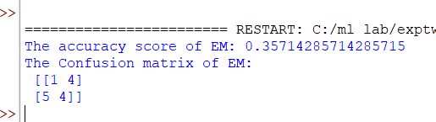

EXPNO:20

import pandas as pd

import numpy as np

from sklearn.model_selection import train_test_split

from sklearn.linear_model import LinearRegression

import plotly.io as io

io.renderers.default = 'browser'

data = pd.read_csv('C:/ml lab/futuresale prediction.csv')

print(data.head())

print(data.sample(5))

print(data.isnull().sum())

import plotly.express as px

import plotly.graph_objects as go

figure = px.scatter(data_frame=data, x="Sales", y="TV", size="TV", trendline="ols")

figure.show()

figure = px.scatter(data_frame=data, x="Sales", y="Newspaper", size="Newspaper", trendline="ols")

figure.show()

figure = px.scatter(data_frame=data, x="Sales", y="Radio", size="Radio", trendline="ols")

figure.show()

correlation = data.corr()

print(correlation["Sales"].sort_values(ascending=False))

x = np.array(data.drop(["Sales"], axis=1))

y = np.array(data["Sales"])

xtrain, xtest, ytrain, ytest = train_test_split(x, y, test_size=0.2, random_state=42)

model = LinearRegression()

model.fit(xtrain, ytrain)

print(model.score(xtest, ytest))

features = np.array([[230.1, 37.8, 69.2]]) # Modify the values according to your needs

print(model.predict(features))

OUTPUT:

